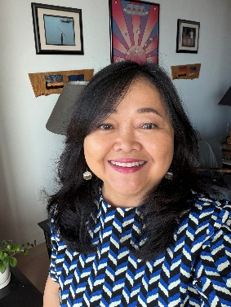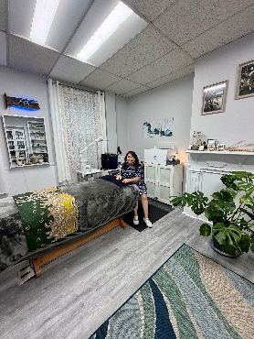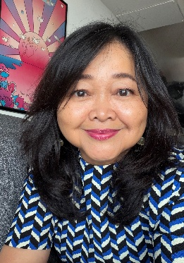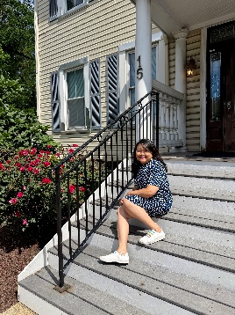

Local Stories
https://voyagemaryland.com/interview/inspiring-conversations-with-ari-chibbaro-of-ari-wax-skin-llc/

July 16, 2026 - Inspiring Conversations with Ari Chibbaro of Ari Wax & Skin, LLC

Hi Ari, we’d love for you to start by introducing yourself.
I went to Esthetician school in 2005, became licensed immediately after, and worked at several spas in Maryland. The idea to open my own studio came after bad treatment from my last employer. While I was on vacation in 2018, I received texts from my regular clients who were unable to book with me. I told one that I was on vacation and maybe there’s a glitch on the system. Another was told I was not available and the employer would see her, so she became upset thinking I refused to see her. Other clients texted me saying they were told that I moved to different state. When I returned from vacation, my employer gave me an envelope with my last paycheck. I also saw my information removed from their web site – in effect, letting me go with no notice and no reason. This drama in the spa industry was sad for clients but prompted me to consider my future options. While relaxing and enjoy the quiet moments for several months, I decided to open my own studio to care for my clients and continue my philanthropic efforts without any more disruptions. With help from my husband and friends, I began this new chapter in my career and life in Rockville, MD in late 2018.

I’m sure it wasn’t obstacle-free, but would you say the journey has been fairly smooth so far?
As we all know in today’s economy, it is not easy to run a small business – especially one considered to be in the “luxury” category. I must adjust on daily basis how to approach each client based on the history of our relationship. I am open to each of them why I run my business as a fully philanthropic effort – not to make them feel sorry but to help them understand that I am just a bridge to make their skin healthy & beautiful, and at the end of the day their payment will go to help others. If clients need my input on managing their budget, I will openly tell them to prioritize what is most critical in their life. I always be available when needed to rescue their skin when the time is right for them, until the time I retire.
As you know, we’re big fans of Ari Wax & Skin, LLC. For our readers who might not be as familiar what can you tell them about the brand?
Ari Wax Skin is a waxing services and skin treatment studio for men & women in Rockville, Maryland. It is located at 15 West Montgomery Ave, Rockville Maryland 20850. My website is https://www.ariwaxskin.com/. My contact is 240 949 2575.
We offer full-body waxing for men and women (Brazilian area for female only) and customized facial services for men and women according to the client’s skin types, conditions, and needs. I have an online scheduling system; clients can easily communicate with me by text to book their appointment.
I offer a membership program that includes discount prices without the need to sign any agreement for monthly credit card charges. I offer this option because I personally don’t like to see my credit card being charged every month. This program means that clients won’t have extra balances that need to be used before expiration or transfer.
To me, waxing & facials are necessary. I grew up in a spa environment where I started body treatments once I got my first period. Teens everywhere deal with hormonal issues and I am glad that my mom taught me early how to treat my body.
We need to groom & treat ourselves to feel & look good. Relaxation will improve our attitude and give fresh energy for our daily life. We use our body to earn a living; why not treat our body back? Several clients have expressed that my treatments helped them regain confidence and feel presentable in daily life. They share stories about compliments received from family members or colleagues that show how people notice when we take care of our own body. When we interact with others; they will see our face & expression first. Making a good first impression is important in personal and professional settings.
I see each individual who comes to my studio as unique & special. Everyone has different issues and conditions each time. I adjust and customize services depending on these conditions and their needs. I will often downgrade to a lower-priced service if I see that a client doesn’t need the requested costlier service. Honesty is my priority because I love what I do.
Contact Info:
- Website: https://www.ariwaxskin.com/
- Instagram: https://www.instagram.com/ari_waxskin/
- Facebook: https://www.facebook.com/ariwaxskin/
- LinkedIn: http://www.linkedin.com/in/ariwaxskin
- Yelp: https://www.yelp.com/biz/ari-wax-skin-rockville

